**PRACTICAL - 1**

**AIM:**

Evaluation of Database (File System, DBMS, RDBMS, DDBMS).

**File System:­­­­­­­­­­­**

* A File Management system is a DBMS that allows acceSs to single files or tables at a time. In a File System, data is directly stored in set of files. It contains flat files that have no relation to other files (when only one table is stored in single file, then this file is known as flat file).
* It helps you to organizes the data and allows easy retrieval of files when they are required. It mostly consists of different types of files like mp3, mp4, txt, doc, etc. that are grouped into directories.
* A file system enables you to handle the way of reading and writing data to the storage medium. It is directly installed into the computer with the Operating systems such as Windows and

**Features of a File system:**

Here are important elements of the file system:

* It helps you to store data in a group of files.
* Files data are dependent on each other.
* C/C++ and COBOL languages were used to design the files.
* Shared File System Support
* Fast File System Recovery.

**DBMS:**

* A Database Management System (DBMS) is software designed to store, retrieve, define, and manage data in a database.
* DBMS software primarily functions as an interface between the end user and the database, simultaneously managing the data, the database engine, and the database schema in order to facilitate the organization and manipulation of data.

**Features of DBMS:**

* A user-accessible catalog of data
* Transaction support
* Concurrency control with Recovery services
* Authorization services
* The value of data is the same at all places.
* Offers support for data communication
* Independent utility services
* Allows multiple users to share a file at the same time

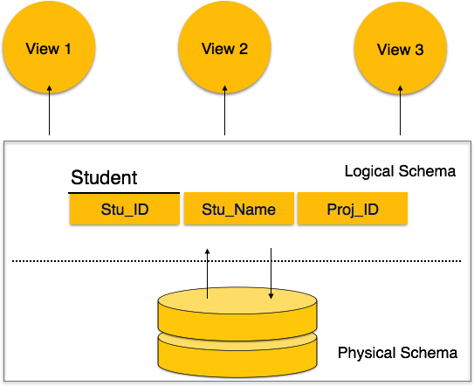

* DBMS software primarily functions as an interface between the end user and the database, simultaneously managing the data, the database engine, and the database schema in order to facilitate the organization and manipulation of data.
* Though functions of DBMS vary greatly, general-purpose DBMS features and capabilities should include: a user accessible catalogue describing metadata, DBMS library management system, data abstraction and independence, data security, logging and auditing of activity, support for concurrency and transactions, support for authorization of access, access support from remote locations, DBMS data recovery support in the event of damage, and enforcement of constraints to ensure the data follows certain rules.

**RDBMS:**

* A relational database management system (RDBMS) refers to a collection of programs and capabilities that is designed to enable the user to create, update, and administer a [relational database](https://www.omnisci.com/technical-glossary/relational-database), which is characterized by its structuring of data into logically independent tables, normally including a Structured Query Language (SQL) application programming interface
* All modern database management systems like SQL, MS SQL Server, IBM DB2, ORACLE, My-SQL and Microsoft Access are based on RDBMS.
* It is a DBMS in which the database is organized and accessed according to the relationships between data items. In a relational database, relationships between data items are expressed by means of tables. Interdependencies among these tables are expressed by data values rather than by pointers. This allows a high degree of data independence.

**DDBMS:**

* A distributed database management system (DDBMS) is a set of multiple, logically interrelated databases distributed over a network. They provide a mechanism that makes the distribution of data transparent to users.
* Databases in the collection are logically interrelated with each other. Often they represent a single logical database.
* Data is physically stored across multiple sites. Data in each site can be managed by a DBMS independent of the other sites.
* The processors in the sites are connected via a network. They do not have any multiprocessor configuration.

**DIFFERENCE**

**1.File System vs DBMS**

|  |  |
| --- | --- |
| **File System** | **DBMS** |
| File system is a software that manages and organizes the files in a storage medium within a computer**.** | DBMS is a software for managing the database. |
| It doesn’t provide backup and recovery of data if it is lost. | It provides backup and recovery of data even if it is lost. |
| Redundant data can be present in a it. | In it there is no redundant data. |
| There is less data consistency in file system | There is more data consistency because of the process of normalization. |
| There is no efficient query processing in file system. | Efficient query processing is there in DBMS. |
| There is no data independence. | In DBMS data independence exists. |
| File systems provide less security in comparison to DBMS. | DBMS has more security mechanisms as compared to file system. |

**2. DBMS VS RDBMS**

|  |  |
| --- | --- |
| **DBMS** | **RDBMS** |
| DBMS stores data as file. | RDBMS stores data in tabular form. |
| Data elements need to access individually. | Multiple data elements can be accessed at the same time. |
| DBMS does not support distributed database. | RDBMS supports distributed database. |
| Normalization is not present. | Normalization is present. |
| It deals with small quantity of data. | It deals with large amount of data. |
| It supports single user. | It supports multiple users. |
| The data in a DBMS is subject to low security levels with regards to data manipulation. | The data in a DBMS is subject to low security levels with regards to data manipulation. |
| Data fetching is slower for the large amount of data. | Data fetching is fast because of relational approach. |
| Examples: XML, Window Registry, etc | Examples: MySQL, PostgreSQL, SQL Server, Oracle, Microsoft Access etc. |